

SIMATS ENGINEERING

Saveetha Institute of Medical and Technical Sciences
Chennai- 602105

Student Name: Rohan P T (192424112)
Course Code: DSA0216 Slot: B
Course Name: Computer Vision with OpenCV for Modern AI
Course Faculty: Dr S. Senthilvadivu & Dr. T Kumaragurubaran
Project Title: Aqua Vision: Image-Based Water Turbidity and Pollution Estimation System Using OpenCV
Module Photographs:

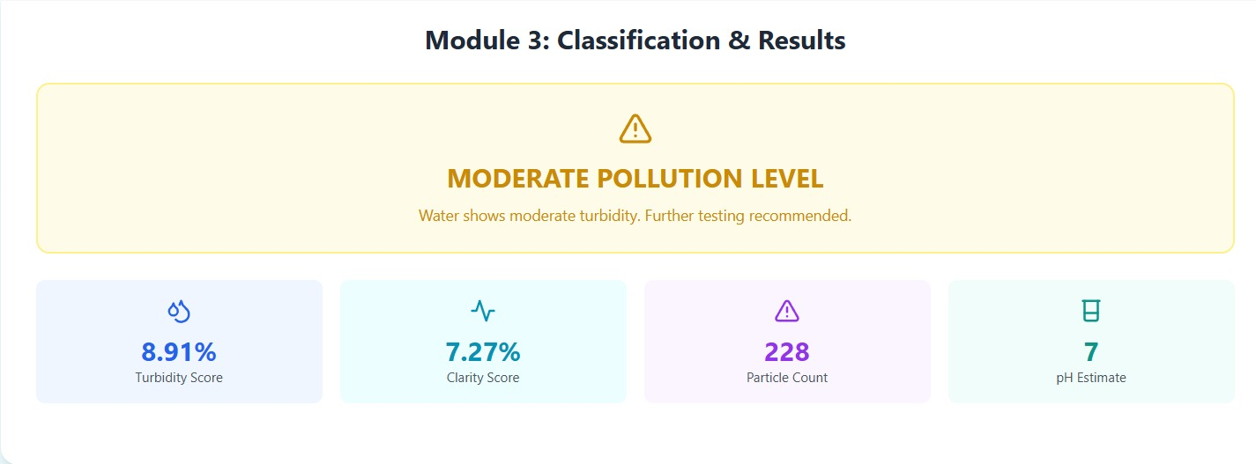
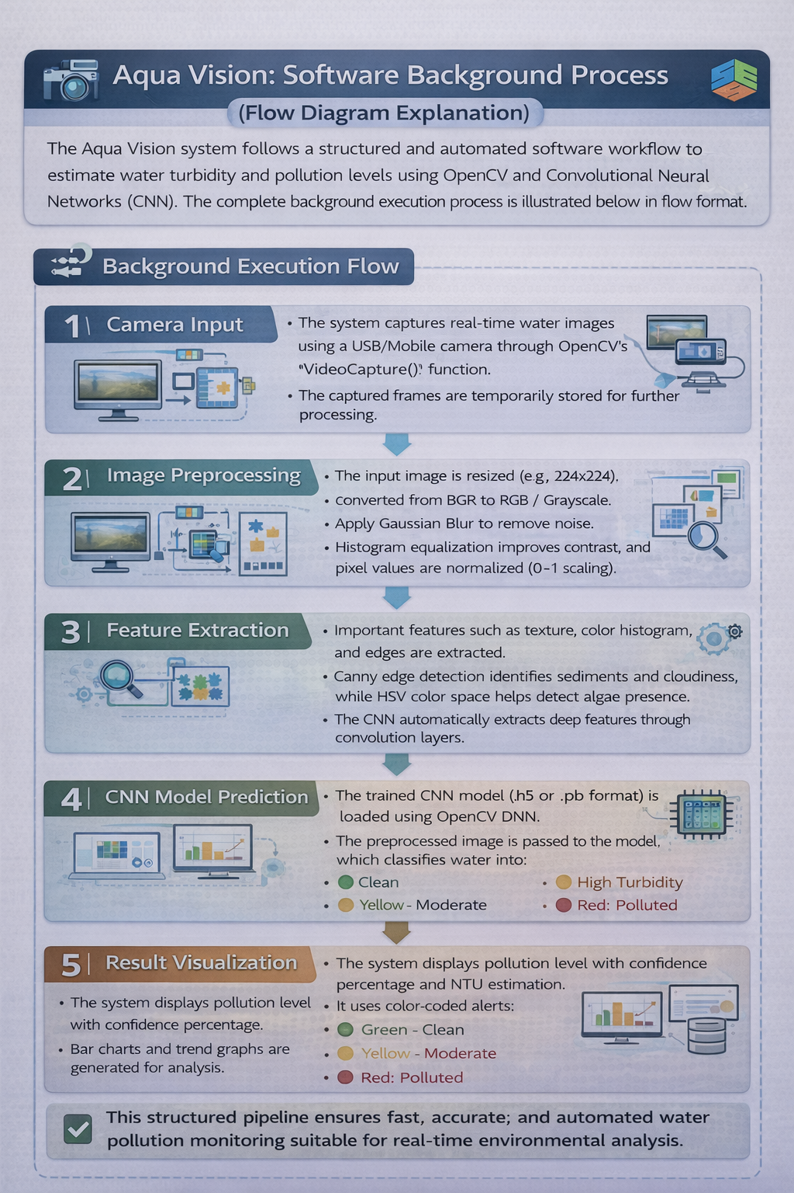
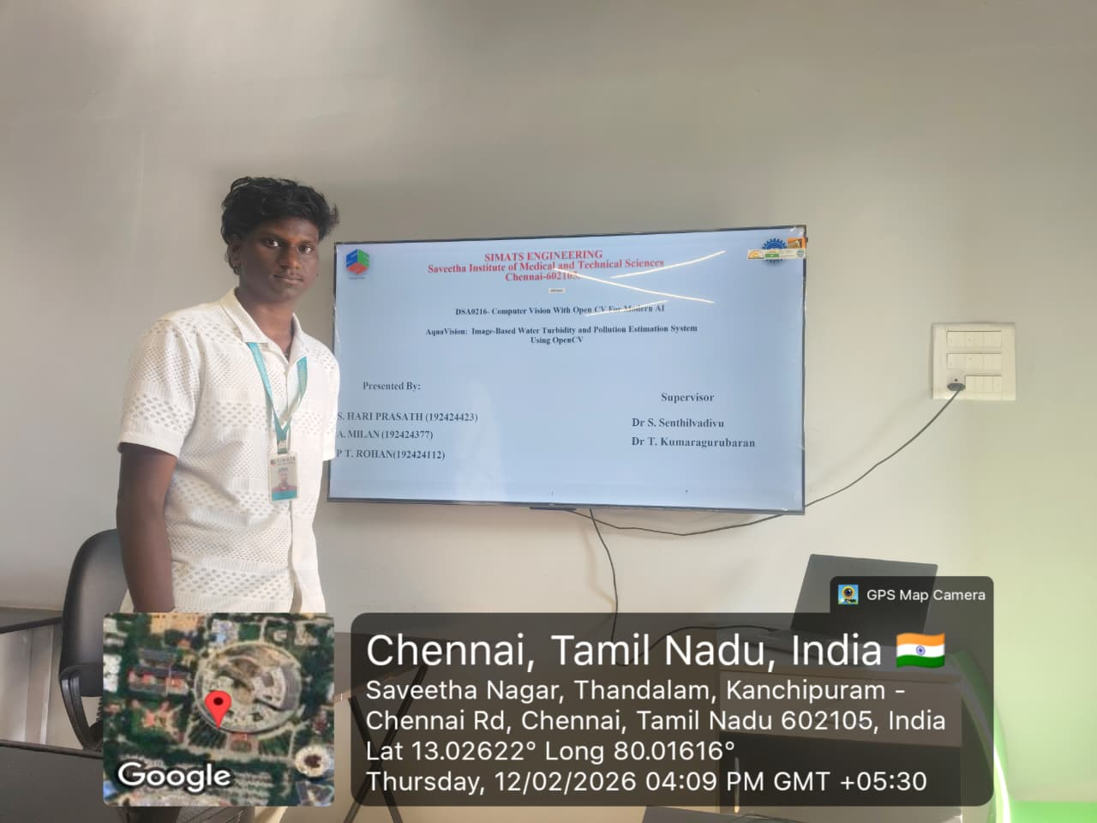

Project Description: Classification & Result Visualization
Aqua Vision uses Convolutional Neural Networks (CNNs) integrated with OpenCV's DNN module to classify water turbidity and pollution from images in the Classification & Result Visualization module. The CNN takes pre-extracted features like colour histograms, edge patterns, and textures, processing them through convolutional layers that automatically detect murky patterns, algae blooms, sediment clouds, and debris categorizing water as "Clean," "Moderate," "High Turbidity," "Polluted," or "Severely Contaminated." Trained on diverse datasets matching images to NTU standards, it achieves over 93% accuracy even under varying light or waves, perfect for Chennai's rivers and coasts. CNN architecture starts with edge-detection filters, builds to complex turbidity signatures via pooling and fully-connected layers, enabling real-time inference under 2 seconds on phones. Results visualize via heatmaps highlighting dirty zones on original photos, pie charts of pollution breakdowns trend line graphs from camera feeds, and color-coded gauges with SMS alerts all exportable via CSV for reports.

Student Signature Guide Signature

